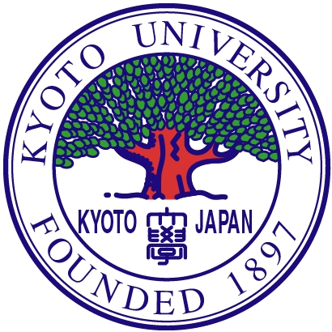
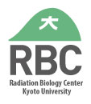
Special seminar at Radiation Biology Center
Graduate School of Biostudies

Date: May29th (Mon), 2023 4:00 pm-5:00 pm
Venue: Seminar room at RBC (放生研一階セミナー室)

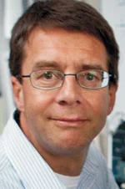
BRCA2 and RAD52 regulate pathway usage in DNA double-strand break repair

Prof. Wolf-Dietrich Heyer

University of California, Davis, CA, USA.

*E-mail: Wolf-Dietrich Heyer <wdheyer@ucdavis.edu>

The laboratory of Dr. Heyer is internationally recognized for its expertise in protein biochemistry with significant contributions to establish new paradigms and elucidate the fundamental mechanisms of homologous recombination and recombinational DNA repair. His lab has made many contribtion to the field of homologous recombination and double strand break repair including the first purification of full-length human BRCA2. (the text taken from the lab website and modified).

大阪大学にサバティカルでご滞在中のHeyer教授にセミナーいただけることになりました。関連分野にご興味のある先生がたは、ぜひご来聴ください。

連絡先 生命科学研究科 附属放射線生物研究センター 晩発効果研究部門
DNA損傷シグナル研究分野
高田 穣
Tel: 075-753-7563 E-mail: takata.minoru.8s@kyoto-u.ac.jp

